Interim Progress Review Report:

Group Name: APA

Andrew Sio(asio896)

Andy Kweon(skwe902)

Phoenix Doolan(pdoo984)

Game Design, Specifications and Project Brief

The goal of this mini project is to design the game Flappy Bird and implement it on the DE0 board in VHDL. The game will be controlled and played by the user using a PS/2 mouse, DIP switches and push buttons on the DE0 board. This game will be displayed on a VGA board with a resolution of 640 x 480 pixels.

The objective of the game is to keep the bird alive by avoiding obstacles such as pipes. The player is able to keep the bird flying by using the left click on the mouse in which they will make the bird fly in between the pipes. If the bird is not flapping it will free-fall towards the ground.

The plan for this mini project is to have to have two game modes, a training mode and single player mode. Training mode will start at the lowest level and allow the user to keep going until the bird dies. It will have pop up text on how to control the bird and the basics of the game. If the player loses, then it will have a menu in which they can restart the training mode or go back to the main menu.

In single player mode, the player will be given a specific number of lives at the start of the game. The player will continue with the game until their lives run out in which they can restart the single player mode or go back to the main menu. If the user hits an obstacle such as the pipes, the bird will lose a life and respawn where the life was lost.

The difference between single player mode and training mode is that single player mode will not have pop up text for the basics of the game. Also in single player mode, the level will increase as the user progresses through the game after avoiding a certain number of obstacles. As the levels increase the speed will also increase.

For our bonus feature, the user can change between a daytime or nighttime colour scheme using the DIP switch 0. The mystery box in our game that the user can pick up using their bird will allow the bird to go through obstacles without losing their life. The bird will change colour and be visible when they pick up the mystery box.

Block Diagram

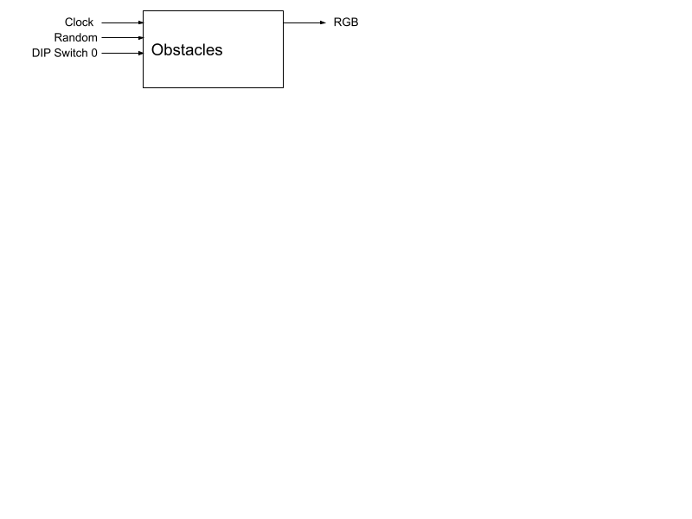

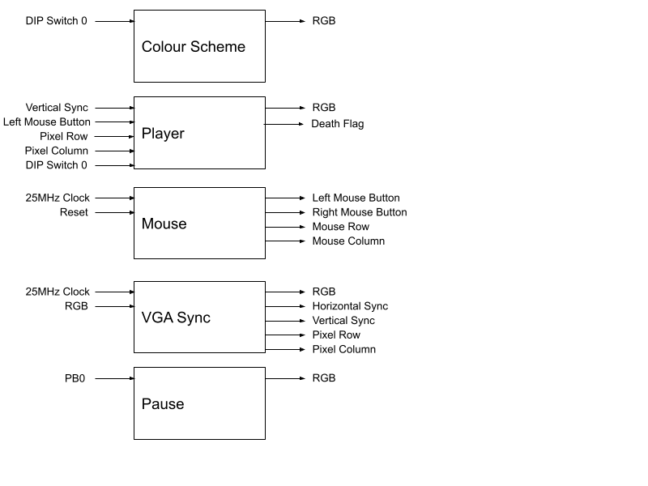

State Machine

